|  |  |  |  |  |  |
| --- | --- | --- | --- | --- | --- |
|  | **Local crystallographic phase detection and texture mapping in ferroelectric Zr doped** | | | | |
| **HfO2 films by transmission-EBSD** | |  | | |
|  | Cite as: Appl. Phys. Lett. **115**, 222902 (2019); <https://doi.org/10.1063/1.5129318> Submitted: 27 September 2019 . Accepted: 11 November 2019 . Published Online: 27 November 2019 | | | | |
|  | [M. Lederer](https://aip.scitation.org/author/Lederer%2C+M) , [T. Kämpfe](https://aip.scitation.org/author/K%C3%A4mpfe%2C+T), [R. Olivo](https://aip.scitation.org/author/Olivo%2C+R), [D. Lehninger](https://aip.scitation.org/author/Lehninger%2C+D), [C. Mart](https://aip.scitation.org/author/Mart%2C+C) , [S. Kirbach](https://aip.scitation.org/author/Kirbach%2C+S), [T. Ali](https://aip.scitation.org/author/Ali%2C+T) , [P. Polakowski](https://aip.scitation.org/author/Polakowski%2C+P), [L. Roy](https://aip.scitation.org/author/Roy%2C+L),  and [K. Seidel](https://aip.scitation.org/author/Seidel%2C+K) | | | | |
|  | **COLLECTIONS** | | | | |
|  | This paper was selected as an Editor’s Pick | | | |
|  | | |  |  |
|  | **ARTICLES YOU MAY BE INTERESTED IN**  [Observation of anomalous Ettingshausen effect and large transverse thermoelectric conductivity in permanent magnets](https://aip.scitation.org/doi/10.1063/1.5131001)  Applied Physics Letters **115**, 222403 (2019); <https://doi.org/10.1063/1.5131001>  [Transmorphic epitaxial growth of AlN nucleation layers on SiC substrates for high-breakdown thin GaN transistors](https://aip.scitation.org/doi/10.1063/1.5123374)  Applied Physics Letters **115**, 221601 (2019); <https://doi.org/10.1063/1.5123374>  [Femtosecond-time-resolved imaging of the dielectric function of ZnO in the visible to near-IR spectral range](https://aip.scitation.org/doi/10.1063/1.5128069)  Applied Physics Letters **115**, 212103 (2019); <https://doi.org/10.1063/1.5128069> | | | | |
| Appl. Phys. Lett. **115**, 222902 (2019); <https://doi.org/10.1063/1.5129318> | | **115**, 222902 | | |
| © 2019 Author(s). | | | | |

|  |  |  |  |
| --- | --- | --- | --- |
| Applied Physics Letters | ARTICLE | |  | | --- | | [scitation.org/journal/apl](https://scitation.org/journal/apl) | |

Local crystallographic phase detection and texture mapping in ferroelectric Zr doped HfO2 films by transmission-EBSD

|  |  |  |  |  |  |  |  |  |
| --- | --- | --- | --- | --- | --- | --- | --- | --- |
| Cite as: Appl. Phys. Lett. 115, 222902 (2019); doi: [10.1063/1.5129318](https://doi.org/10.1063/1.5129318) Submitted: 27 September 2019.Accepted: 11 November 2019[.](https://doi.org/10.1063/1.5129318) | | | | |  |  |  |  |
| Published Online: 27 November 2019 | | | | |
| M. Lederer,a) |  | T. K€ampfe, R. Olivo, D. Lehninger, C. Mart, |  | S. Kirbach, T. Ali, |  | P. Polakowski, L. Roy, and K. Seidel | | |

AFFILIATIONS   
Fraunhofer IPMS, K€onigsbr€ucker Str. 178, 01099 Dresden, Germany

a)Electronic mail: [maximilian.lederer@ipms.fraunhofer.de](mailto:maximilian.lederer@ipms.fraunhofer.de)

ABSTRACT   
The local crystal phase and orientation of ferroelectric grains inside TiN/Hf0.5Zr0.5O2/TiN have been studied by the analysis of the local electron beam scattering Kikuchi patterns, recorded in transmission. Evidence was found that the ferroelectric phase of the layers is derived from an orthorhombic phase, most likely of space group Pca21. The orientation analysis reveals a strong out-of-plane texture of the polycrystalline film which is in accordance with a high remanent polarization Pr observed for P-V measurements. The results of this analysis help us to further optimize the ratio of ferroelectric grains and their orientation for many applications, e.g., in the field of emerging memory or infrared sensors.

Published under license by AIP Publishing. <https://doi.org/10.1063/1.5129318>

Highly textured ferroelectric films are required for high den-sity nonvolatile memories such as ferroelectric field-effect transis-tors (FeFET),1ferroelectric random-access memories (FeRAM),2 and ferroelectric tunneling junctions (FTJs).3Since the discovery of ferroelectricity in ultrathin layers of Si doped HfO2,4ferroelec-tric properties have been demonstrated in polycrystalline HfO2 films doped with various elements such as Y, Sr, Al, Si, or Zr.3 Even undoped HfO2 has been reported to exhibit ferroelectric properties,5which proves that ferroelectricity is an intrinsic prop-erty of the confined material.

HfO2 is fully compatible with conventional complementary metal-oxide semiconductor (CMOS) processes and can be manu-factured using many approaches, including atomic layer deposition (ALD). Therefore, it may prove superior to traditional perovskite structure based ferroelectric materials with regard to the applica-bility in ferroelectric devices. So far, highly scaled FeFETs with thin ferroelectric HfO2 layers have been fabricated at 28 nm6and 22 nm7technology node high-k metal gate (HKMG) CMOS pro-cesses. Furthermore, the observed piezoelectric8and pyroelectric9 properties reveal potential for future nanoelectromechanical sys-tems (NEMS) and sensor applications.

It has been reported that the ferroelectricity of HfO2 originates from the orthorhombic phase with the space group Pca21 10 [Fig. 1(a)]. As this is a metastable phase, a multitude of different crystallographic

phases and associated textures can be present in the films, which is influenced by external conditions such as stress,11doping,3thermal treatment,12and film thickness.13   
 Besides the phase of space group Pca21, two other orthorhombic phases, with the space group Pbca and Pnma, respectively, have been reported in the literature. These two phases are stabilized by high pres-sure, but they do have an inversion center which does not allow ferroelectricity.11   
 However, the local orientation of the HfO2 grains as well as their crystallographic phase is of vital importance with regard to its ferro-electric as well as its associated piezoelectric and pyroelectric proper-ties both for materials science and practical applications.

In this article, the analysis of the local electron back-scattering diffraction (EBSD) patterns is used to reveal the crystallographic phase and its local orientation. In contrast to conventional EBSD, transmission-EBSD, also called low-energy transmission Kikuchi dif-fraction (TKD), enables the analysis of thin films in the nanometer scale. Furthermore, the lateral spatial resolution is strongly improved, thus allowing to obtain indexable EBSD patterns for lateral grain sizes down to 10 nm as demonstrated by Keller and Geiss.14They suggested it could help us to determine the phase of more complex crystal struc-tures due to the increased resolution of the finer structure within the diffraction pattern.14This originates from the narrower energy distri-bution of the transmitted electrons.14

|  |  |
| --- | --- |
| Appl. Phys. Lett. 115, 222902 (2019); doi: 10.1063/1.5129318 | 115, 222902-1 |

Published under license by AIP Publishing

|  |  |  |  |
| --- | --- | --- | --- |
| Applied Physics Letters | ARTICLE | |  | | --- | | [scitation.org/journal/apl](https://scitation.org/journal/apl) | |

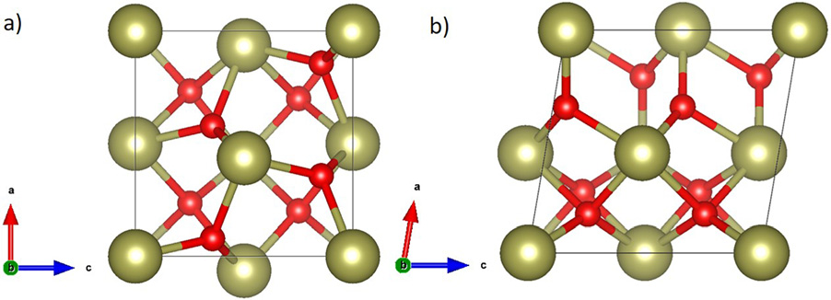

|  |
| --- |
| FIG. 1. The crystal structure of hafnium oxide for (a) the ferroelectric orthorhombic |

|  |
| --- |
| (Pca21) and (b) the monoclinic (P21/c) phase as calculated by DFT. |

The investigated sample was prepared by depositing 10 nm TiN on a highly p-doped silicon wafer using ALD followed by the deposi-tion of 10 nm Hf0.5Zr0.5O2 (HZO) via ALD at 250�C using HfCl4 and ZrCl4 precursors. After physical vapor deposition (PVD) of a 10 nm TiN capping layer, the sample was annealed at 800�C utilizing a rapid thermal spike process.

For the electrical analysis of the metal-ferroelectric-metal (MFM) capacitors, the structures were patterned by depositing metal (Ti/Pt) contacts using a shadow mask with a subsequent SC1 TiN wet etch. Dynamic hysteresis measurements (DHM) with an amplitude of 3 V and a frequency of 1 kHz were conducted using an aixACCT TF Analyzer 3000 measurement setup. Cycling pulses were performed with the same amplitude and frequency. For the grazing incidence X-ray diffraction (GIXRD) scan, a Bruker D8 Discover XRD system was utilized, collecting patterns in a 2h range between 10�and 90�at a fixed incident angle of 0.5�.

Using a dimple grinder, the sample was prepared for the TKD measurement. The TKD measurement was performed in a scanning electron microscope (SEM) with a Bruker Optimus TKD detector. The sample is located perpendicular to the beam, with the detector posi-tioned below the sample [Fig. 2(a)]. The applied accelerating voltage was 30 kV. As the scattered electrons are likely to exit the sample at Bragg conditions, the resulting patterns on the detector are determined by the local periodicity of the material before leaving the sample.14

|  |
| --- |
| Since the electron beam transmits first through the TiN top electrode |

|  |
| --- |
| layer followed by the HZO layer before leaving the sample, the |

|  |
| --- |
| Kikuchi patterns of the TiN crystal structure should appear in the |

|  |
| --- |
| form of an increased noise level or weak artifacts in the detector |

|  |
| --- |
| image. |

Kikuchi patterns, as shown in Fig. 2(b), were measured for each point in the scanned region. By taking the scatter signal intensity at every position, a visualization, called quality map, can be constructed

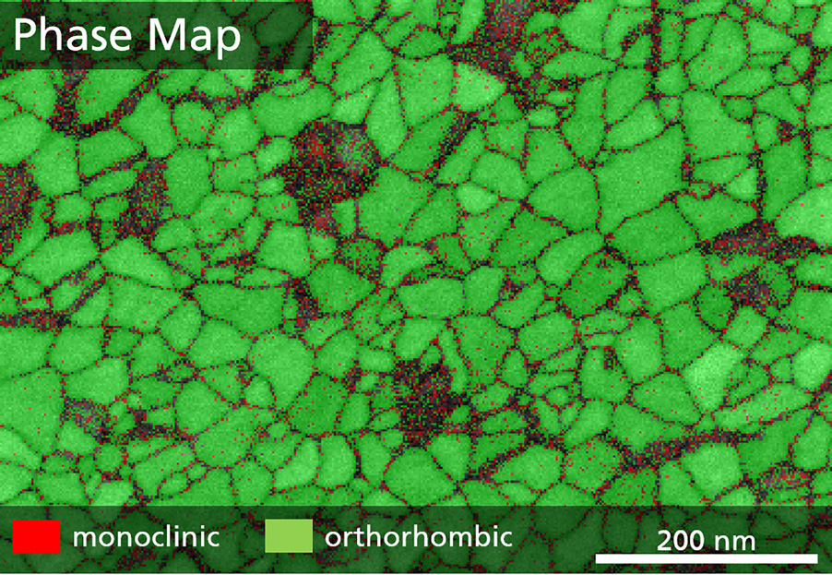

|  |
| --- |
| FIG. 3. The phase of local grains is identified from the fitted Kikuchi patterns. Due to fitting with monoclinic and orthorhombic phase only, tetragonal/cubic grains could have been identified as orthorhombic. |

[Fig. 2(c)]. Here, individual grains can already be distinguished. Large angle grain boundaries appear as black lines due to their low symme-try, whereas crystalline grains appear white due to their higher symme-try. Since the measurement is performed in transmission, grain boundaries appear sharp as most grain radii exceed the layer thickness, thus being present in a columnar like shape.

In order to extract the crystallographic phase of the individual grains, the detector image undergoes a Hough transformation, which allows us to detect lines and extract their position and orien-tation. Next, the simulated Kikuchi patterns of the monoclinic (P21/c) as well as the ferroelectric orthorhombic (Pca21) phase were compared and oriented to the extracted ones. As shown by the green and red lines in Fig. 2(b), respectively, the aligned theo-retical patterns of the two phases fit well with the measured detec-tor image of two representative positions. By performing this for each measurement point, the so-called phase map can be extracted (Fig. 3). It should be noted that TKD does not allow us to deter-mine the lack of an inversion center. Therefore, the space group cannot be uniquely determined.

When comparing these results with the polarization-voltage (P-V) hysteresis loops measured by DHM [Fig. 4(a)], the high fraction of orthorhombic phase fits well with the high remanent polarization (Pr) found after wake-up of the sample. Furthermore, the TKD results are supported by the GIXRD pattern shown in Fig. 4(b). Here, strong

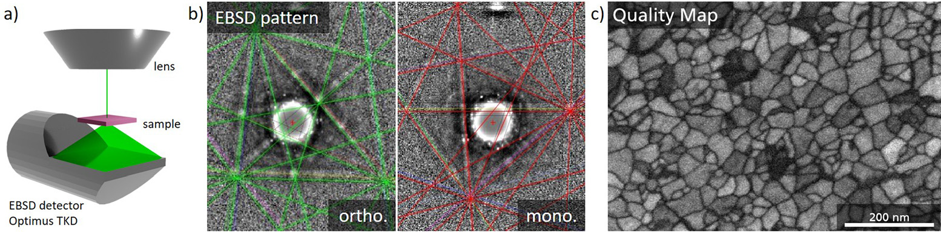

|  |  |  |
| --- | --- | --- |
| |  | | --- | | FIG. 2. Transmission Kikuchi diffraction of HZO. A schematic of the experimental setup is given in (a). The measured detector image for two positions is given in (b). The appearing Kikuchi pattern can be fitted with the theoretical Kikuchi lines calculated from the given crystal structures, shown as green lines for the orthorhombic phase and as red lines for the monoclinic phase. The quality map (c) visualizes the contrast of the detector image, thus displaying the grain image. | | |
| Appl. Phys. Lett. 115, 222902 (2019); doi: 10.1063/1.5129318 | 115, 222902-2 |

Published under license by AIP Publishing

|  |  |  |  |
| --- | --- | --- | --- |
| Applied Physics Letters | ARTICLE | |  | | --- | | [scitation.org/journal/apl](https://scitation.org/journal/apl) | |

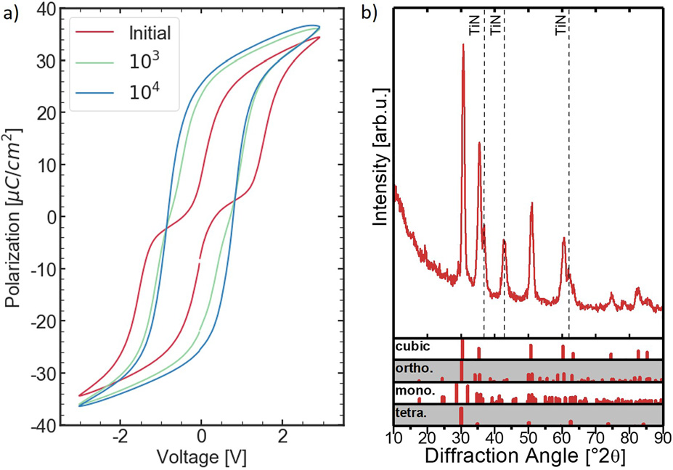

|  |
| --- |
| FIG. 4. P-V hysteresis loops (a) and GIXRD pattern (b) of the Hf0.5Zr0.5O2 sample. The hysteresis opens during field cycling (wake-up effect). Afterward, the measured remanent polarization reaches a high value of about 27 lC=cm2, indicating a high orthorhombic phase fraction. The GIXRD pattern shows diffraction lines at the expected position for the orthorhombic phase, whereas the expected peaks for the monoclinic phase do not appear clearly. Thus, an insignificant fraction of monoclinic phase is expected. |

intensities appear at the expected diffraction lines for orhorhombic/ tetragonal/cubic phase, whereas the diffraction lines for monoclinic phase are not distinguishable from the noise. However, the P-V hyster-esis loops as well as the GIXRD pattern do not allow us to extract the local and accurate phase distribution. On the contrary, this can be real-ized by TKD measurements as shown in Fig. 3.

In Fig. 5, the grain size distribution of the monoclinic and orthorhombic phase is displayed. The mean equivalent diameter of the orthorhombic grains lies at about 29 nm, ranging from about 10-70 nm, whereas the monoclinic grains have a mean grain size of about 34 nm, with grain sizes down to about 20 nm. The presence of monoclinic phase in larger grains is in agreement with the predictions made by density functional theory (DFT) calculations of thermody-namics of the HfO2 material system.11This is attributed to the

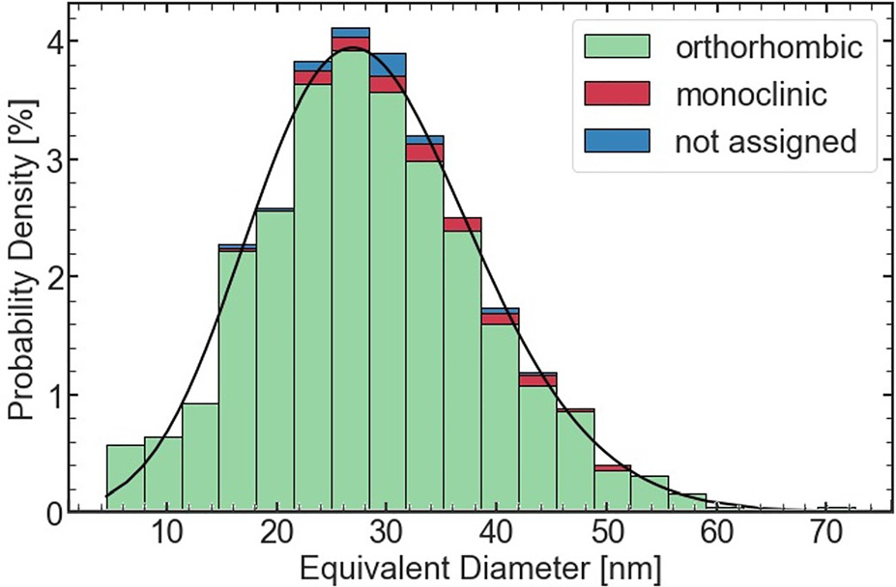

|  |
| --- |
| FIG. 5. Grain size distribution of the monoclinic and orthorhombic phase. The grain |

|  |
| --- |
| size distribution is extracted from the phase and quality map. Grains smaller than 5 nm are disregarded. The overall grain size distribution fits well with a lognormal distribution. |

monoclinic phase being the most stable phase of bulk hafnium oxide.11 By taking into account the surface energy, DFT calculations have

|  |
| --- |
| shown that for small grain sizes the tetragonal phase is more stable. |

Furthermore, it has been reported that the orthorhombic phase is only favored at the thermodynamical boundary between monoclinic and tetragonal phase with a narrow range of grain radii smaller than 2:5 nm.15With increasing temperature, the stable region of the ortho-rhombic phase closes and the tetragonal phase is favored for increasing grain sizes.11   
 The high amount of orthorhombic grains larger than the expected 2:5 nm can be explained by kinetics. Due to the high energy barrier for the phase transformation from tetragonal to monoclinic, this transition is suppressed. On the other hand, the energy barrier of the phase transition from tetragonal to orthorhombic is much smaller.11As the sample is annealed by RTP, small tetragonal nuclei in the amorphous matrix will grow at high temperatures. Upon cool-down, the tetragonal phase becomes unstable for large grains and switches to the orthorhombic phase.15Since the monoclinic phase is favored for larger grains, some of them can overcome the energy bar-rier and switch to monoclinic upon cooldown, thus explaining the grain distribution presented in Fig. 5 consisting of 3.2% monoclinic and 95.0% orthorhombic grains.

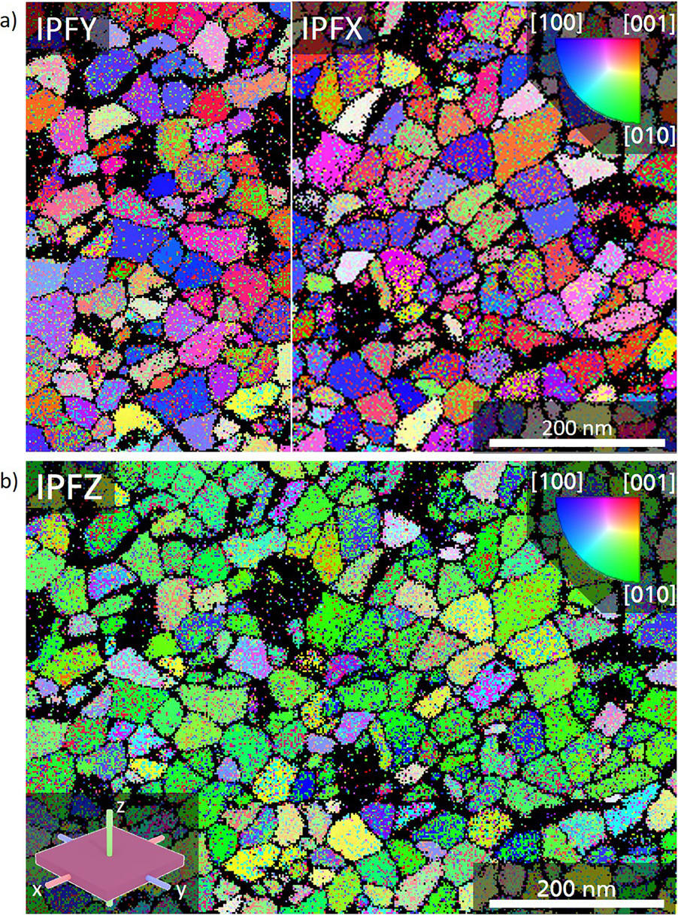

|  |
| --- |
| FIG. 6. Grain orientation along the x-/y- and z-axis of the sample (IPFX/IPFY (a) and IPFZ (b) map, respectively). Visualized is the grain orientation extracted from |

|  |
| --- |
| the Kikuchi pattern by color coding of the unit cell axis which is parallel to the respective sample-axis. For the HZO sample, many grains are present with the [010]-axis pointing out-of-plane (along the z-axis), thus indicating a film texture. |

|  |  |
| --- | --- |
| Appl. Phys. Lett. 115, 222902 (2019); doi: 10.1063/1.5129318 | 115, 222902-3 |

Published under license by AIP Publishing

|  |  |  |  |
| --- | --- | --- | --- |
| Applied Physics Letters | ARTICLE | |  | | --- | | [scitation.org/journal/apl](https://scitation.org/journal/apl) | |

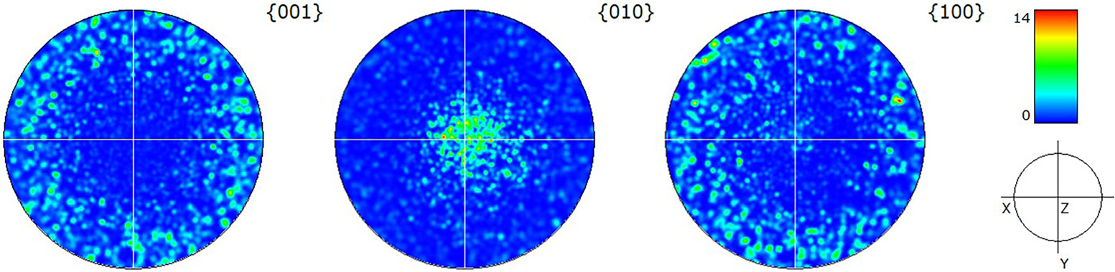

|  |
| --- |
| FIG. 7. Stereographic projection of the crystal planes. The 010  f 001 g-planes are oriented parallel to the z-axis. Yet, in contrast to the 010 f g-planes are mostly oriented perpendicular to the z-axis of the sample. Consequently, most of the 100  g-planes, they do not have a texture inside the xy-orientations of the sample.   g- and |

Besides phase identification, TKD enables the orientation mapping of nanocrystalline materials.16With the extracted grain orientation, the

the ferroelectric orthorhombic phase is present in the full range of grain sizes. This is in agreement with theories based on the ther-

|  |  |  |  |  |  |  |  |  |
| --- | --- | --- | --- | --- | --- | --- | --- | --- |
| pole figure (PF)/inverse pole figure (IPF) of each measurement point | modynamic | and | kinetic | nature | of | doped | hafnium | oxide. |

can be calculated. Taking the three sample planes, the orientation of the orthorhombic grains can be visualized as the so-called IPF-maps (Fig. 6). The xy-plane, which describes the out-of-plane directions of the thin film, shows a clear texture, whereas the xz/yz-planes show no in-plane texture. Accordingly, most grains are oriented with the [010]-axis pointing out-of-plane.

The origin for the texture could be explained by stress conditions during the crystallization and phase transitions. Recent findings by Schenk et al. for La doped HfO2 also report a textured polycrystalline film with the longest axis lying in-plane. They suggested that the

|  |
| --- |
| hafnium oxide layer compensates tensile stress during cooldown by |

aligning the longest axis in-plane.17Since the phase transition from the tetragonal phase will occur upon cooldown, tensile stress condi-tions promote a preferred alignment of the longer unit cell axes to be lying in-plane. As [010] is the shortest axis of the Pca21 unit cell, the

|  |
| --- |
| out-of-plane texture should be related to the [010]-axis. |

This behavior can be seen in the PFs of the unit cell axes (Fig. 7). The short [010]-axis lies mostly in the z-direction, whereas the longer [100]- and [001]-axis lie randomly oriented in-plane of the thin film.

Since the [001]-axis, which resembles the polarization axis, would lie closely aligned with the in-plane direction, a low remanent polariza-tion would be expected for the sample. On the contrary, P-V results show a high Pr after wake-up. An explanation for this can be derived from the published data on epitaxial films.18,19The [010]-axis of their film is oriented perpendicular to the films surface after growth. During the electroforming step, they found that the [010]- and [001]-axes switch, thus resulting in an out-of-plane orientation of the polarization axis.19This agrees with the measured P-V data [Fig. 4(a)] as the initial hysteresis is pinched strongly, but it opens up with subsequent cycling. Furthermore, the TKD measurement was performed on the film before wake-up. Consequently, this is a strong indication that also in ferroelectric polycrystalline HfO2 films, the [010]- and [001]-axes are switching during the wake-up effect.

In conclusion, it is demonstrated that transmission Kikuchi diffraction enables a high-resolution, local, and accurate measure-ment of the phase fraction of HfO2. Furthermore, the crystallo-

|  |
| --- |
| graphic orientation of individual grains is determined, thus |

|  |
| --- |
| allowing us to investigate the texture of the hafnium oxide thin |

film. By applying this technique to a HZO thin film, it is found that the monoclinic phase is only present in a small fraction of rel-atively large size grains (3.2% of the total grain count), whereas

Furthermore, an out-of-plane texture of the [010]-axis was found in the polycrystalline film, which can be explained by persistent tensile strain during the annealing step. Combined with electrical data, this suggests a switching of the [010]- and the polar [001]-axis during wake-up in ferroelectric polycrystalline HfO2 films.

This research was supported by the ECSEL Joint Undertaking project WAKeMeUP in collaboration with the European Union’s H2020 Framework Program (No. H2020/2014-2020) and National Authorities under Grant Agreement No. 783176. Furthermore, we received technical support from Bruker and Globalfoundries.

REFERENCES

1S. M€uller, J. M€uller, R. Hoffmann, E. Yurchuk, T. Schlosser, R. Boschke, J. Paul, M. Goldbach, T. Herrmann, A. Zaka, U. Schr€oder, and T. Mikolajick, [IEEE Trans. Electron Devices](https://doi.org/10.1109/TED.2013.2283465) 60, 4199 (2013).

2J. M€uller, T. S. B€oscke, S. M€uller, E. Yurchuk, P. Polakowski, J. Paul, D. Martin, T. Schenk, K. Khullar, A. Kersch, W. Weinreich, S. Riedel, K. Seidel, A. Kumar, T. M. Arruda, S. V. Kalinin, T. Schlosser, R. Boschke, R. van Bentum, U. Schr€oder, and T. Mikolajick, in IEDM (2013), pp. 10.8.1–10.8.4.

3J. M€uller, P. Polakowski, S. M€uller, and T. Mikolajick, [ECS J. Solid State Sci. Technol.](https://doi.org/10.1149/2.0081505jss) 4, N30 (2015).

4T. S. B€oscke, J. M€uller, D. Br€auhaus, U. Schr€oder, and U. B€ottger, [Appl. Phys. Lett.](https://doi.org/10.1063/1.3634052) 99, 102903 (2011).

5P. Polakowski and J. M€uller, [Appl. Phys. Lett.](https://doi.org/10.1063/1.4922272) 106, 232905 (2015).

6J. M€uller, E. Yurchuk, T. Schlosser, J. Paul, R. Hoffmann, S. Muller, D. Martin, S. Slesazeck, P. Polakowski, J. Sundqvist, M. Czernohorsky, K. Seidel, P. Kucher, R. Boschke, M. Trentzsch, K. Gebauer, U. Schroder, and T. Mikolajick, in VLSI (2012), pp. 25–26.

7S. Dunkel, M. Trentzsch, R. Richter, P. Moll, C. Fuchs, O. Gehring, M. Majer, S. Wittek, B. Muller, T. Melde, H. Mulaosmanovic, S. Slesazeck, S. Muller, J. Ocker, M. Noack, D.-A. Lohr, P. Polakowski, J. Muller, T. Mikolajick, J. Hontschel, B. Rice, J. Pellerin, and S. Beyer, in IEDM (2017), pp. 19.7.1–19.7.4.

8P. Buragohain, C. Richter, T. Schenk, H. Lu, T. Mikolajick, U. Schroeder, and A. Gruverman, [Appl. Phys. Lett.](https://doi.org/10.1063/1.5030562) 112, 222901 (2018).

9C. Mart, T. K€ampfe, S. Zybell, and W. Weinreich, [Appl. Phys. Lett.](https://doi.org/10.1063/1.5019308) 112, 052905 (2018).

10X. Sang, E. D. Grimley, T. Schenk, U. Schroeder, and J. M. LeBeau, [Appl. Phys.](https://doi.org/10.1063/1.4919135)  [Lett.](https://doi.org/10.1063/1.4919135) 106, 162905 (2015).

11R. Materlik, C. K€unneth, and A. Kersch, [J. Appl. Phys.](https://doi.org/10.1063/1.4916707) 117, 134109 (2015).

12L. Xu, T. Nishimura, S. Shibayama, T. Yajima, S. Migita, and A. Toriumi, [J. Appl. Phys.](https://doi.org/10.1063/1.5003918) 122, 124104 (2017).

|  |  |
| --- | --- |
| Appl. Phys. Lett. 115, 222902 (2019); doi: 10.1063/1.5129318 | 115, 222902-4 |

Published under license by AIP Publishing

|  |  |  |  |
| --- | --- | --- | --- |
| Applied Physics Letters | ARTICLE | |  | | --- | | [scitation.org/journal/apl](https://scitation.org/journal/apl) | |

13E. Yurchuk, J. M€uller, S. Knebel, J. Sundqvist, A. P. Graham, T. Melde, U.

Schr€oder, and T. Mikolajick, [Thin Solid Films](https://doi.org/10.1016/j.tsf.2012.11.125) 533, 88 (2013).

14R. R. Keller and R. H. Geiss, [J. Microsc.](https://doi.org/10.1111/j.1365-2818.2011.03566.x) 245, 245 (2012).

15M. H. Park, Y. H. Lee, H. J. Kim, Y. J. Kim, T. Moon, K. D. Kim, S. D. Hyun, T.

Mikolajick, U. Schr€oder, and C. S. Hwang, [Nanoscale](https://doi.org/10.1039/C7NR06342C) 10, 716 (2018). 16P. W. Trimby, [Ultramicroscopy](https://doi.org/10.1016/j.ultramic.2012.06.004) 120, 16 (2012).

17T. Schenk, C. M. Fancher, M. H. Park, C. Richter, C. K€unneth, A. Kersch, J. L.

Jones, T. Mikolajick, and U. Schroeder, [Adv. Electron. Mater.](https://doi.org/10.1002/aelm.201900303) 5, 1900303 (2019). 18T. Shimizu, K. Katayama, T. Kiguchi, A. Akama, T. J. Konno, and H. Funakubo, [Appl. Phys. Lett.](https://doi.org/10.1063/1.4927450) 107, 032910 (2015).

19T. Shimizu, T. Mimura, T. Kiguchi, T. Shiraishi, T. J. Konno, Y. Katsuya, O. Sakata, and H. Funakubo, [Appl. Phys. Lett.](https://doi.org/10.1063/1.5055258) 113, 212901 (2018).

|  |  |
| --- | --- |
| Appl. Phys. Lett. 115, 222902 (2019); doi: 10.1063/1.5129318 | 115, 222902-5 |

Published under license by AIP Publishing